**Name- Yash Chandra**

**Section-E**

**Class Roll Number-62**

**University Roll Number-2014954**

**Subject Code- PCS 693**

**Subject Name- Web Development Lab**

**Assignment Number-02**

**Branch – CSE Core**

Q-1 WAP in HTML to implement a frame.



Solution-

Here we have 6 file and connect them

**1. File Name- q1.html**

Code-

<!doctype html>

<html>

<head>

<title> question-1</title>

</head>

<frameset cols = "20%,80%">

<frame name = "menu_page" src = "/html/part1.html" />

<frame name="main_page" src= "/html/main.html" />

<noframes>

<body>Your browser does not support frames.</body>

</noframes>

</frameset>

</html>

**2. File Name- part-1**

Code-

<!doctype html>

<html>

<style>

.ab

{

text-align:center;

color:red;

}

</style>

<body bgcolor="BlanchedAlmond">

<h2 class="ab">Selected Planets</h2>

<p> Read essential Details </p>

<p>about the following </p>

<p> planets:</p>

<ul>

<li><a href="/html/venus.html" target="main_page" >Venus</a></li>

<br>

<li><a href="/html/earth.html" target="main_page">Earth</a></li>

<br>

<li><a href="/html/jupiter.html" target="main_page">Jupiter</a></li>

</ul>

</body>

</html>

**3. File Name- main.html**

Code-

<!doctype>

<html>

<body bgcolor="Beige">

<h1 align="center"> Welcome </h1>

</body>

</html>

**4. File Name- venus.html**

Code-

<!doctype html>

<html>

<style>

.ab

{

text-align:center;

color:red;

}

</style>

<body bgcolor="Beige">

<h2 class="ab"> Venus</h2>

<img align="right" src="venus.jpg" alt="venus planet" width="300px" height="300px">

<p> Venus is the second planet from the Sun and is Earth’s closest planetary neighbor.

It’s one of the four inner, terrestrial (or rocky) planets, and it’s often called Earth’s twin because it’s similar in size and density.

These are not identical twins, however – there are radical differences between the two worlds.</p>

<p>

Venus has a thick, toxic atmosphere filled with carbon dioxide and it’s perpetually shrouded in thick, yellowish clouds of sulfuric acid that trap heat, causing a runaway greenhouse effect.

It’s the hottest planet in our solar system, even though Mercury is closer to the Sun.

Surface temperatures on Venus are about 900 degrees Fahrenheit (475 degrees Celsius) – hot enough to melt lead.

The surface is a rusty color and it’s peppered with intensely crunched mountains and thousands of large volcanoes.

Scientists think it’s possible some volcanoes are still active.

</p>

<p>

Venus has crushing air pressure at its surface – more than 90 times that of Earth – similar to the pressure you'd encounter a mile below the ocean on Earth.

</p>

<p>

Another big difference from Earth – Venus rotates on its axis backward, compared to most of the other planets in the solar system.

This means that, on Venus, the Sun rises in the west and sets in the east, opposite to what we experience on Earth.

(It’s not the only planet in our solar system with such an oddball rotation – Uranus spins on its side.)

Venus was the first planet to be explored by a spacecraft – NASA’s Mariner 2 successfully flew by and scanned the cloud-covered world on Dec. 14, 1962.

Since then, numerous spacecraft from the U.S. and other space agencies have explored Venus, including NASA’s Magellan, which mapped the planet's surface with radar.

Soviet spacecraft made the most successful landings on the surface of Venus to date, but they didn’t survive long due to the extreme heat and crushing pressure.

An American probe, one of NASA's Pioneer Venus Multiprobes, survived for about an hour after impacting the surface in 1978.

More recent Venus missions include ESA’s Venus Express (which orbited from 2006 until 2016) and Japan’s Akatsuki Venus Climate Orbiter (orbiting since 2016).

NASA’s Parker Solar Probe has made multiple flybys of Venus. On Feb. 9, 2022, NASA announced the spacecraft had captured it first visible light images of the surface of Venus from space during its February 2021 flyby.

</p>

<p>

In June 2021, three new missions to Venus were announced. NASA announced two new missions, and ESA announced one:

</p>

<p>

VERITAS: NASA's VERITAS, or Venus Emissivity, Radio Science, InSAR, Topography, and Spectroscopy, will be the first NASA spacecraft to explore Venus since the 1990s. The spacecraft will launch no earlier than December 2027. It will orbit Venus, gathering data to reveal how the paths of Venus and Earth diverged, and how Venus lost its potential to be a habitable world.

</p>

<p>

DAVINCI: NASA’s DAVINCI mission will launch in the late 2020s. After exploring the top of Venus’s atmosphere, DAVINCI will drop a probe to the surface. On its hour-long descent, the probe will take thousands of measurements and snap up-close images of the surface. The probe may not survive the landing, but if it does, it could provide several minutes of bonus science.

</p>

<p>

EnVision: ESA has selected EnVision to make detailed observations of Venus. As a key partner in the mission, NASA is providing the Synthetic Aperture Radar, called VenSAR, to make high-resolution measurements of the planet’s surface features.

</p>

</body>

</html>

**5.File Name- Earth.html**

Code-

<!doctype html>

<html>

<style>

.ab

{

text-align:center;

color:red;

}

</style>

<body bgcolor="Beige">

<h2 class="ab"> Earth</h2>

<img align="right" src="earth.jpg" alt="venus planet" width="300px" height="300px">

<p>

Our home planet is the third planet from the Sun, and the only place we know of so far that’s inhabited by living things.

</p>

<p>

While Earth is only the fifth largest planet in the solar system, it is the only world in our solar system with liquid water on the surface. Just slightly larger than nearby Venus, Earth is the biggest of the four planets closest to the Sun, all of which are made of rock and metal.

The name Earth is at least 1,000 years old. All of the planets, except for Earth, were named after Greek and Roman gods and goddesses. However, the name Earth is a Germanic word, which simply means “the ground.”

</p>

<p>

Earth is the third planet from the Sun and the only astronomical object known to harbor life.

While large amounts of water can be found throughout the Solar System, only Earth sustains liquid surface water.

About 71% of Earth's surface is made up of the ocean, dwarfing Earth's polar ice, lakes and rivers.

The remaining 29% of Earth's surface is land, consisting of continents and islands.

Earth's surface layer is formed of several slowly moving tectonic plates, interacting to produce mountain ranges, volcanoes and earthquakes.

Earth's liquid outer core generates the magnetic field that shapes Earth's magnetosphere, deflecting destructive solar winds.

</p>

<br>

<p>

Earth's atmosphere consists mostly of nitrogen and oxygen.

More solar energy is received by tropical regions than polar regions and is redistributed by atmospheric and ocean circulation.

Water vapor is widely present in the atmosphere and forms clouds that cover most of the planet.

Greenhouse gases in the atmosphere like carbon dioxide (CO2) trap a part of the energy from the Sun close to the surface.

A region's climate is governed by latitude, but also by elevation and proximity to moderating oceans.

Severe weather, such as tropical cyclones, thunderstorms, and heatwaves, occurs in most areas and greatly impacts life.

</p>

<br>

<p>

Earth is an ellipsoid with a circumference of about 40,000 km.

It is the densest planet in the Solar System. Of the four rocky planets, it is the largest and most massive.

Earth is about eight light minutes away from the Sun and orbits it, taking a year (about 365.25 days) to complete one revolution.

Earth rotates around its own axis in a day. Earth's axis of rotation is tilted with respect to its orbital plane with the Sun, producing seasons.

Earth is orbited by one permanent natural satellite, the Moon, which orbits Earth at 380,000 km (1.3 light seconds) and is roughly a quarter as wide as Earth.

The Moon always faces the Earth with the same side through tidal locking and causes tides, stabilizes Earth's axis and gradually slows its rotation.

Earth formed over 4.5 billion years ago.

During the first billion years of Earth's history, the ocean formed and then life developed within it. Life spread globally and began to affect Earth's atmosphere and surface, leading to Earth's Great Oxidation Event two billion years ago. Humans emerged 300,000 years ago, and have reached a population of almost 8 billion today. Humans depend on Earth's biosphere and natural resources for their survival, but have increasingly impacted Earth's environment. Today, humanity's impact on Earth's climate, soils, waters and ecosystems is unsustainable, threatening people's lives and causing widespread extinction of other life.

</p>

</body>

</html>

**6. File Name- Jupiter.html**

Code-

<!doctype html>

<html>

<style>

.ab

{

text-align:center;

color:red;

}

</style>

<body bgcolor="Beige">

<h2 class="ab"> Jupiter</h2>

<img align="right" src="jupiter.jpg" alt="venus planet" width="300px" height="300px">

<p>

Jupiter has a long history of surprising scientists – all the way back to 1610 when Galileo Galilei found the first moons beyond Earth.

That discovery changed the way we see the universe.

</p>

<br>

<p>

Fifth in line from the Sun, Jupiter is, by far, the largest planet in the solar system – more than twice as massive as all the other planets combined

</p>

<p>

Jupiter's familiar stripes and swirls are actually cold, windy clouds of ammonia and water, floating in an atmosphere of hydrogen and helium.

Jupiter’s iconic Great Red Spot is a giant storm bigger than Earth that has raged for hundreds of years.

One spacecraft – NASA's Juno orbiter – is currently exploring this giant world.

</p>

<br>

<p>

Jupiter is the fifth planet from the Sun and the largest in the Solar System.

It is a gas giant with a mass more than two and a half times that of all the other planets in the Solar System combined,

but slightly less than one-thousandth the mass of the Sun.

Jupiter is the third brightest natural object in the Earth's night sky after the Moon and Venus.

</p>

<br>

<p>

People have been observing it since prehistoric times; it was named after the Roman god Jupiter, the king of the gods, because of its observed size.

Jupiter is primarily composed of hydrogen, but helium constitutes one-quarter of its mass and one-tenth of its volume.

It likely has a rocky core of heavier elements,[16] but, like the other giant planets, Jupiter lacks a well-defined solid surface.

The ongoing contraction of its interior generates heat greater than the amount received from the Sun.

Because of its rapid rotation, the planet's shape is an oblate spheroid; it has a slight but noticeable bulge around the equator.

The outer atmosphere is visibly segregated into several bands at different latitudes, with turbulence and storms along their interacting boundaries.

A prominent result of this is the Great Red Spot, a giant storm known to have existed since at least the 17th century when telescopes first saw it.

</p>

<br>

<p>

Surrounding Jupiter is a faint planetary ring system and a powerful magnetosphere.

Jupiter's magnetic tail is nearly 800 million km (5.3 AU; 500 million mi) long, covering the entire distance to Saturn's orbit.

Jupiter has 80 known moons and possibly many more,[6] including the four large Galilean moons discovered by Galileo Galilei in 1610: Io, Europa, Ganymede, and Callisto.

Io and Europa are about the size of Earth's Moon; Callisto is almost the size of the planet Mercury, and Ganymede is even larger.

Pioneer 10 was the first spacecraft to visit Jupiter, making its closest approach to the planet in December 1973.

Jupiter has since been explored on several occasions by robotic spacecraft, beginning with the Pioneer and Voyager flyby missions from 1973 to 1979, and later by the Galileo orbiter, which arrived at Jupiter in 1995.

In 2007, the New Horizons visited Jupiter using its gravity to increase its speed, bending its trajectory en route to Pluto.

The latest probe to visit the planet, Juno, entered orbit around Jupiter in July 2016.

Future targets for exploration in the Jupiter system include the probable ice-covered liquid ocean of Europa.

</p>

<br>

</body>

</html>

**Output-**

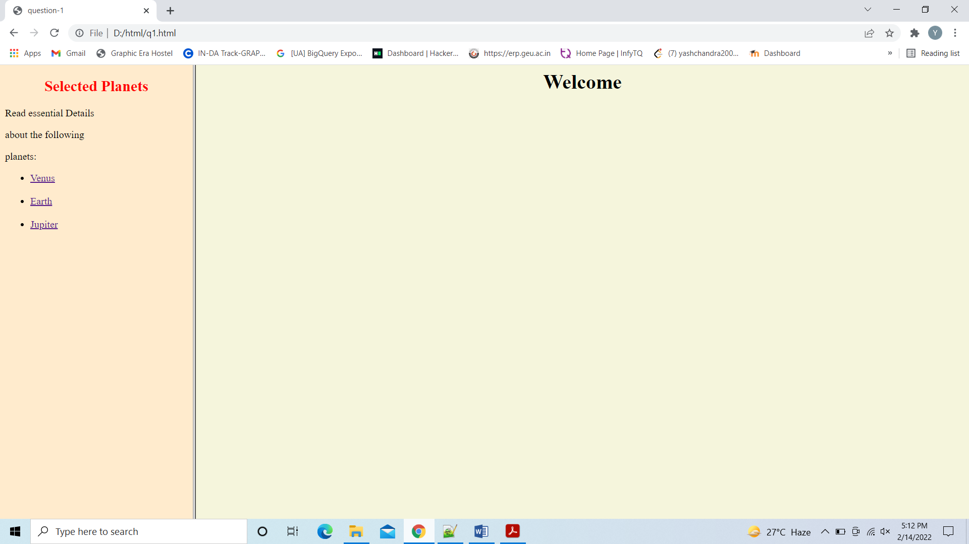

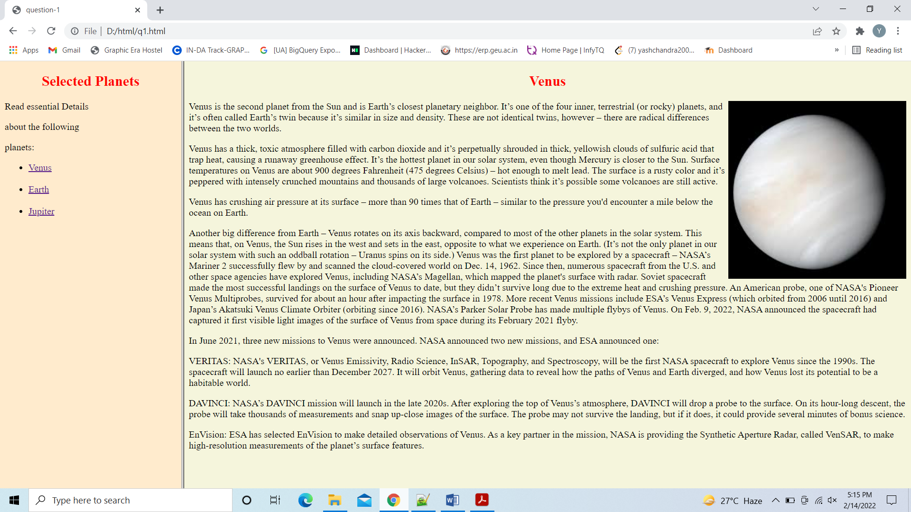

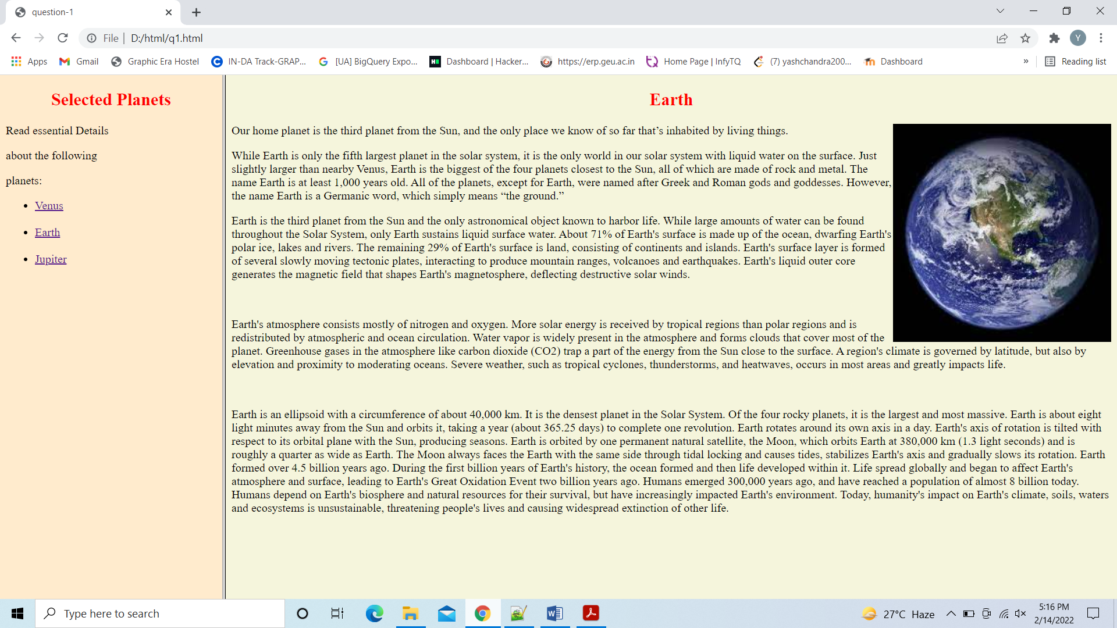

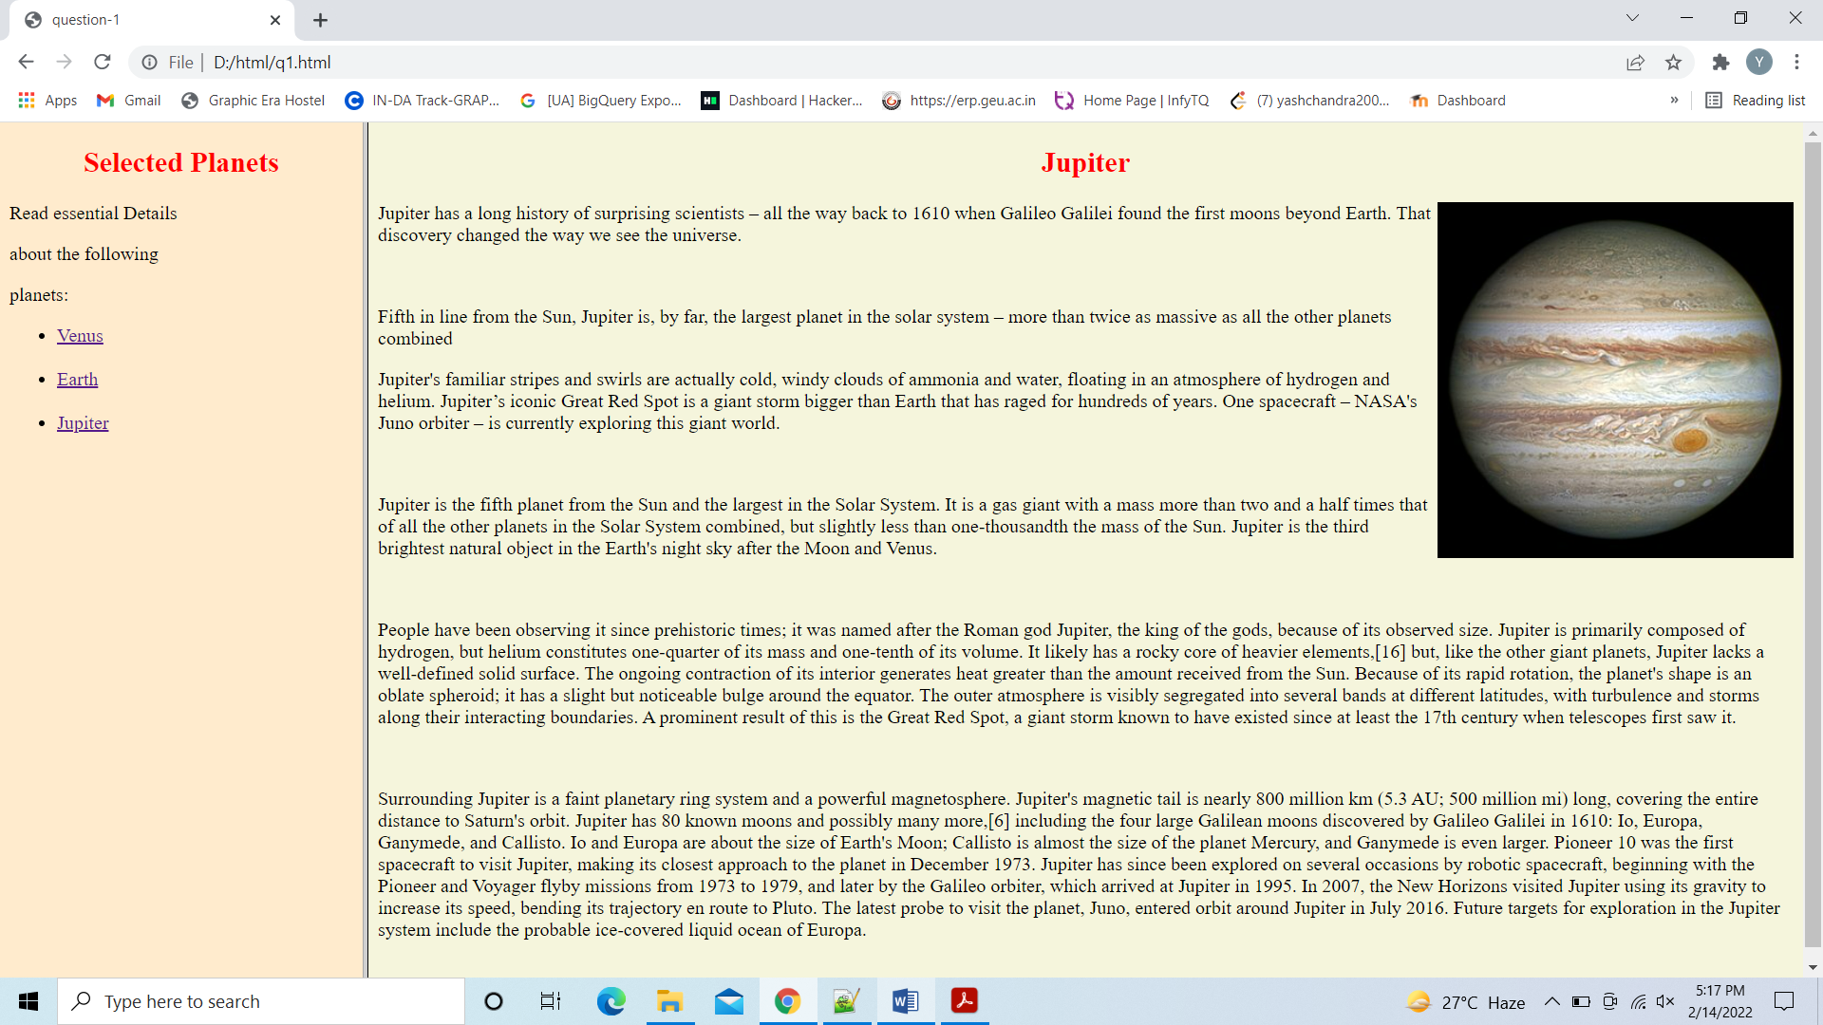

**Q-2 WAP in HTML to implement a table.**



**Code-**

<!doctype html>

<html>

<head>

<title> Question-2</title>

</head>

<body>

<table align="center" border="1" >

<tr>

<th rowspan="3"> Day </th>

<th colspan="3"> Seminar </th>

</tr>

<tr>

<td colspan="2" align="center"> Schedule</td>

<td rowspan="2" align="center"> Topic</td>

</tr>

<tr>

<td align="center">Begin</td>

<td>End</td>

</tr>

<tr>

<td align="middle" rowspan="2"> Monday</td>

<td bgcolor="cornsilk" rowspan="2">8:00 a.m</td>

<td bgcolor="Lavender" rowspan="2">5:00 p.m</td>

<td> Introduction to XML</td>

</tr>

<tr>

<td>Validity:DTD and Relax NG</td>

</tr>

<tr>

<td rowspan="3"> Tuesday</td>

<td bgcolor="cornsilk">8:00 am</td>

<td bgcolor="cornsilk">11:00 am</td>

<td align="center">XPath</td>

</tr>

<tr>

<td bgcolor="cornsilk">11:00 am</td>

<td bgcolor="aquamarine">2:00 pm</td>

<td rowspan="2" align="center">XSL</td>

</tr>

<tr>

<td bgcolor="aquamarine">2:00 pm</td>

<td bgcolor="Lavender ">5:00 pm</td>

<tr>

<td> Wednesday</td>

<td bgcolor="Cornsilk">8:00am</td>

<td bgcolor="aquamarine">12:00 pm</td>

<td>XSL Formatting Objects</td>

</tr>

</table>

</body>

</html>

Output-

